GitHub Repository Evidence
Repository URL
https://github.com/cgorehuela/mis3371-loyalty-rewards-system

Screenshot of Repo Home
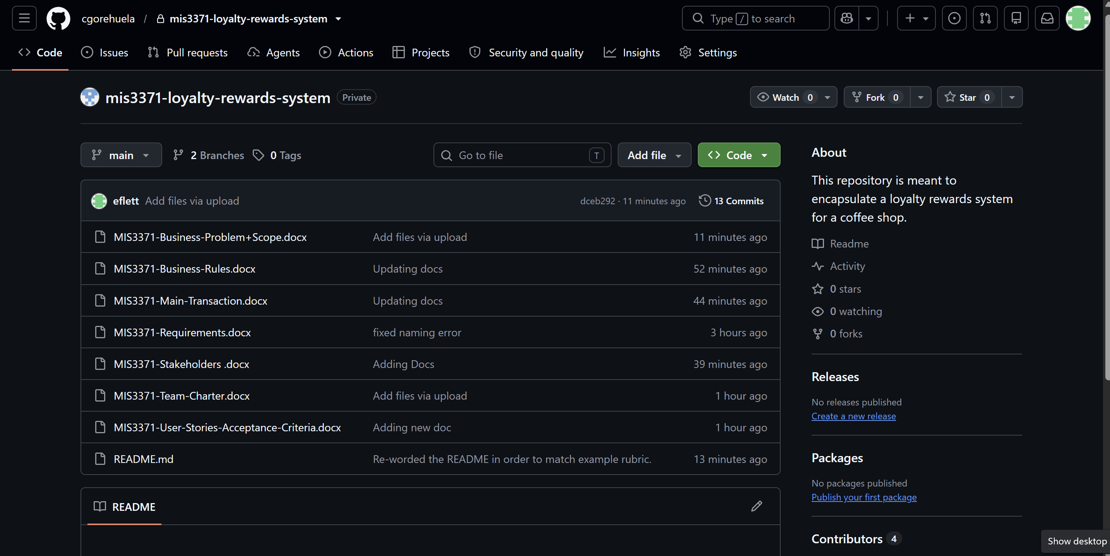
Team Members/Collaborators
Evan Flett - @eflett
Mackenzie Williams- @mwill41
Hailey Do - @haileydo11
Hersatya Dwiputranto- @Satya-Dwiputranto
Clyde Orehuela- @cgorehuela
Andrea Esparza – @aesparz1

First Commit
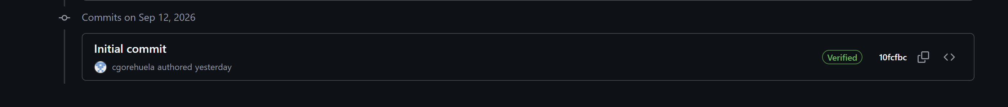

Confirmation everyone can clone/pull
All Team members can clone/pull Repository

